# **User Guide: LLM Red Team Agent for Bid Evaluation**

## **Introduction**

The LLM Red Team Agent is an AI-powered tool designed to review bid submissions against RFP (Request for Proposal) criteria and provide actionable recommendations to improve the bid's strength. This tool is particularly beneficial for bid managers, evaluators, and project teams looking to optimize their submissions for government contracts.

## **How to Use the Tool**

How do I access the Red Team Agent?

*We envisage the red team agent LLM would be accessed via a form, App or web. Dependent on the businesses access and security constraints.*

What documents do I need to upload?

*The bid proposal*

What prompts should I use to start the process?

*The prompt is coded in, you just submit*

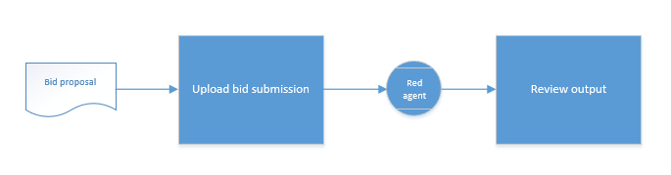

*\*add image of slide when dashboard is added*

## **Understanding the Dashboard**

Where can I access the Dashboard?

*It is envisaged the dashboard would launch when the user submits. The dashboard would also provide access to the stored responses and as the catalogue builds would provide searchable intel.*

What will the Dashboard tell me?

*The response will be recommendations and suggestions; and a score on the quality of the content based on the criteria*

## **Limitations & Troubleshooting**

* The tool relies on the quality of input documents; ensure clarity and completeness before uploading.
* Double-check final outputs against RFP requirements for full compliance.